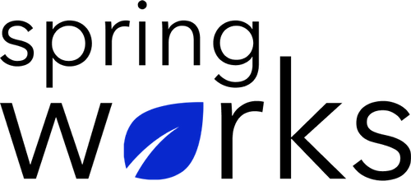
Free Template – Employee Opinion Survey

Use this survey to obtain employee’s opinions about their work and workplace.

This employee opinion survey is conducted to understand employees' strengths and weaknesses by measuring their satisfaction, attitude and other attributes in a range of cultural and performance areas. Copy this template to your Google Drive and customize it for your organization.

Communication (to be added as review instructions):

We can only make positive changes when we have the right information. All answers you give will be treated with the utmost sensitivity, and the information will not be used for any other purpose apart from planning and improvement. Please answer this quick survey by <HOUR OF THE DAY> on <DATE>.

Demographic Information:

The following information is requested so that meaningful analysis and comparisons of group results can be made. Please check the circle, corresponding to your answer.

Q: Your Gender:

- Male
- Female

Q: Your Department:

- Marketing
- Operations
- Tech
- Accounting
- HR

Q: Company Service:

- Under 1 Year
- 1-2 Year
- 3-5 Year
- 6-10 Year
- 10-15 Year
Employee Opinion Questionnaire

To answer clearly what you think or feel about each item, please follow these steps:

- Read each item fully before you start to mark your answer.
- Pick the one answer which most nearly says what you think or how you feel.
- While completing the questions, be sure to read the special instructions which are included.

Choose the answer which is most appropriate (Strongly Agree = 5 and Strongly Disagree =1)

Q: I am Clear about my daily job responsibilities:

- 5
- 4
- 3
- 2
- 1
- N/A

Q: When it comes to operational decision, supervisors seek my opinion:

- 5
- 4
- 3
- 2
- 1
- N/A

Q: I feel free while raising my opinions to the management:

- 5
- 4
- 3
- 2
- 1
- N/A

Q: My skills are optimally utilized by the company:

- 5
- 4
- 3
- 2
- 1
- N/A

Q: A supportive work environment is provided to the employees:

- 5
- 4
- 3
- 2
- 1
- N/A

Q: I think management takes wise decisions:

- 5
- 4
- 3
- 2
- 1
- N/A

Q: My working conditions are quite good:

- 5
- 4
- 3
- 2
- 1
- N/A

Q: We are open culture to share ideas and innovations with each other:

- 5
- 4
- 3
- 2
- 1
- N/A

Q: I am compensated fairly for the work I do:

- 5
- 4
- 3
- 2
- 1
- N/A

Q: The organisation is innovative enough to keep it’s customers satisfied:

- 5
- 4
- 3
- 2
- 1
- N/A

Q: I actively seek feedback from my colleagues and customers to improve:

- 5
- 4
- 3
- 2
- 1
- N/A

Q: I feel well informed and educated about various changes in my daily work?

- 5
- 4
- 3
- 2
- 1
- N/A

Q: I am proud to work with this organisation:

- 5
- 4
- 3
- 2
- 1
- N/A

Q: I would recommend others to work with this organisation:

- 5
- 4
- 3
- 2
- 1
- N/A

Q: The three things you find best in this organisation as compared to other organisations:

i.
ii.
iii.

Q: The three ideas to change current working conditions:

i.
ii.
iii.

Q: What else would you like to tell us about?

Many thanks for taking the time to fill in this survey.

